Dynamic response of an RC beam to a drop weight impact (steel ball)

Ball mass -

Ball material - steel

Modulus of elasticity -

Poisson′s ratio -

Mass density -

Ball volume - = 4/3πR³

Ball radius -

Height of bottom above the beam surface -

Structure type - simply supported beam

Beam length -

Material - reinforced concrete C20/25

Modulus of elasticity -

Poisson′s ratio -

Shear modulus -

Unit weight -

Cross section - rectangular with dimensions:

Width -

Height -

Area -

Second moment of area -

Shear area -

Self-weight -

Uniform load -

Gravity acceleration -

Uniform mass -

Simple analytical solution

The structure is reduced to a SDOF system for simplicity

Dynamically equivalent mass -

Potential energy of the ball before dropping

Kinetic energy immediately before the impact -

The velocity at the moment before the impact is determined by the energy conservation law :

Perfectly inelastic collision model is assumed.

Total mass after contact -

The velocity immediately after the contact is determined by the law of conservation of momentum:

Structural stiffness for a vertical force applied at the middle point of the span

Deflection due to uniform load

Static displacement -

Natural circular frequency -

Vibration period -

Dynamic factor

Dynamic displacement -

Dynamic force -

(without self-weight and uniform load)

Simplified equation for the dynamic factor

The difference will be smaller for greater heights.

Elastic time history response of the structure as an SDOF system

Damped vibration is assumed with factor -

Vibration amplitude - or

Theoretical equation of motion

Solution by direct integration of the impulse load

Duration of impulse transmission for a beam with infinite mass [1]

Duration of impulse transmission for a beam with finite mass [2]

The above values correspond well to the experimental data in [3], where the recorded durations are of a similar magnitude.

The impulse force function will be determined by using the recommended expressions (9.20) - (9.22) in [1]

The coefficient of restitution for perfectly inelastic collision is -

Impulse load diagram

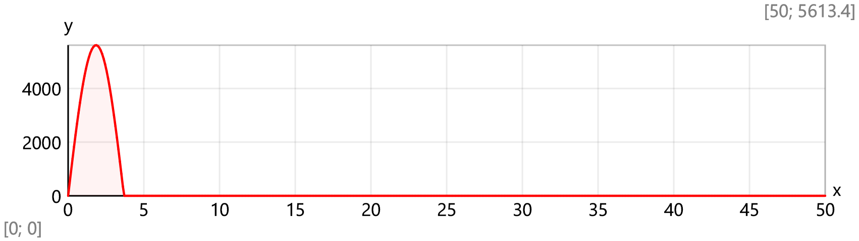

Maximal impulse load value -

The equation of motion is expressed by the Duhamel′s integral

Static displacement for the midpoint of the beam

Dynamic displacement for the midpoint of the beam

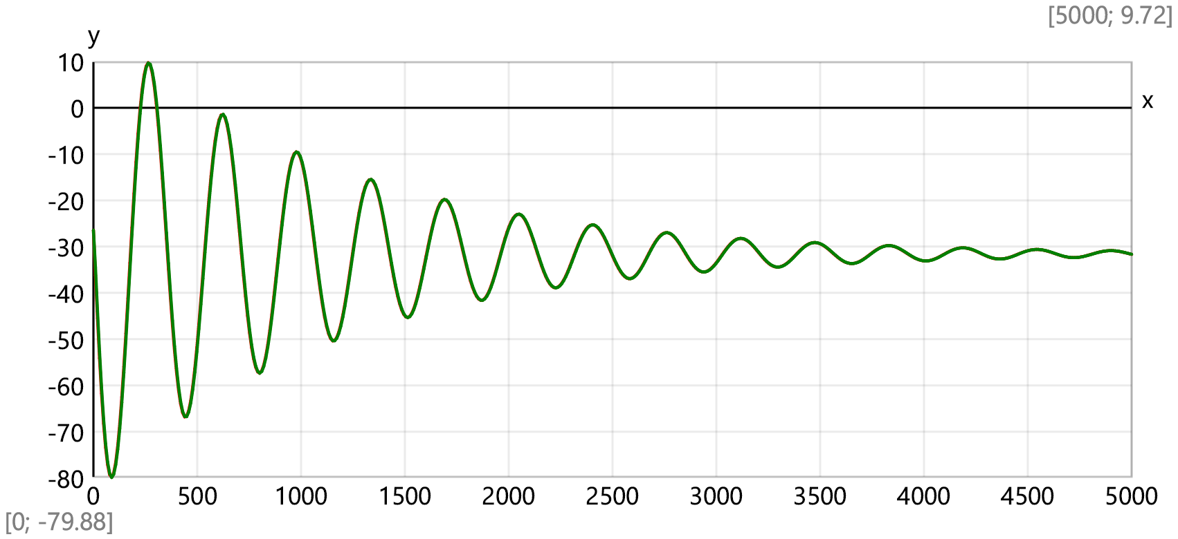

Elastic time history response of the structure as an MDOF system

Number of intermediate joints - (odd)

Length of one segment -

Coordinate of joint *j* -

Shear forces due to unit vertical load *F*j = 1 at joint *j*

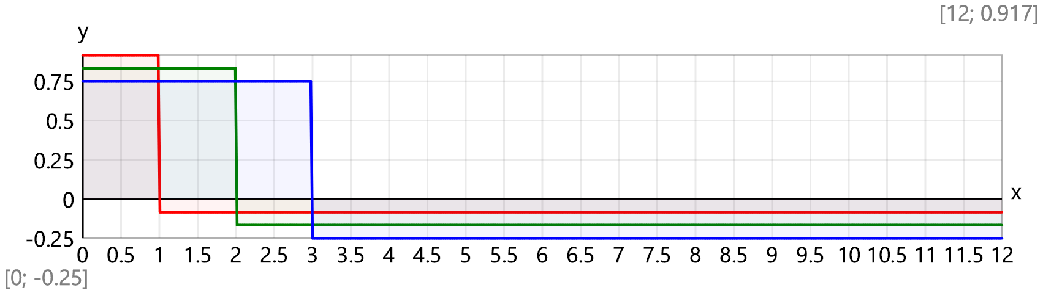

Bending moments due to unit vertical load *F*j = 1 at joint *j*

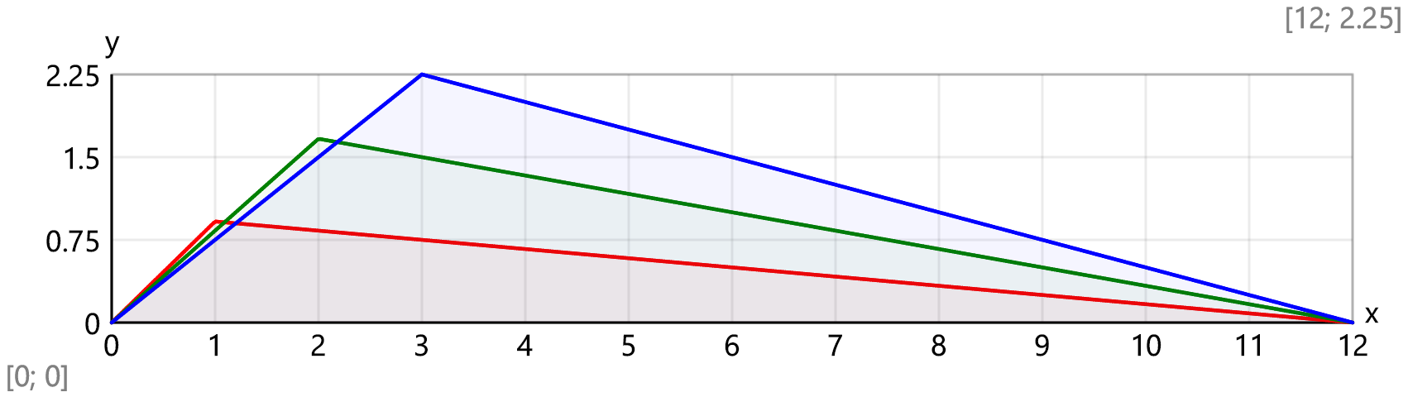

Flexibility matrix

mm/kN

Mass matrix

Total mass of the structure - t

Eigenvalues

Natural circular frequences - *s*⁻¹

Natural vibration frequences -

Natural vibration periods -

Eigenvectors

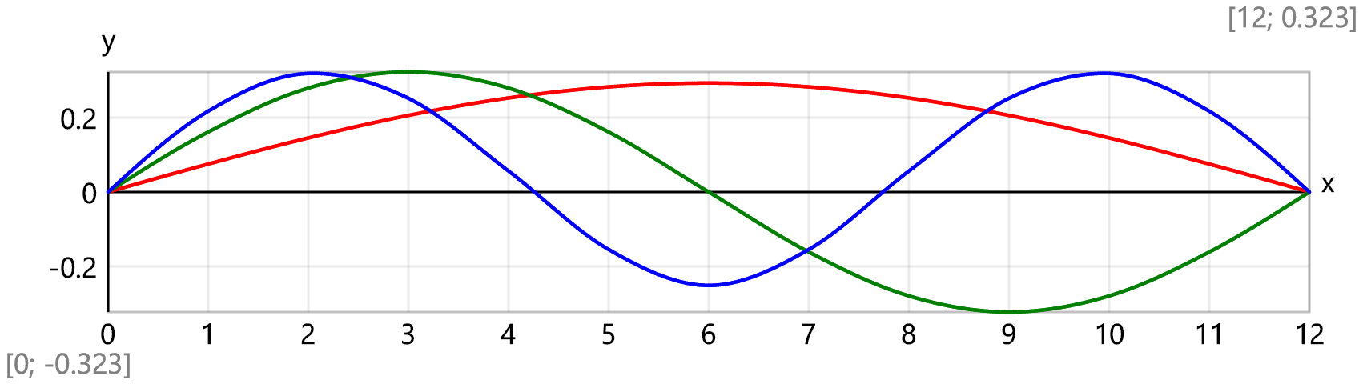

Modal masses -

Rayleigh damping model is assumed

,

Modal damping factors -

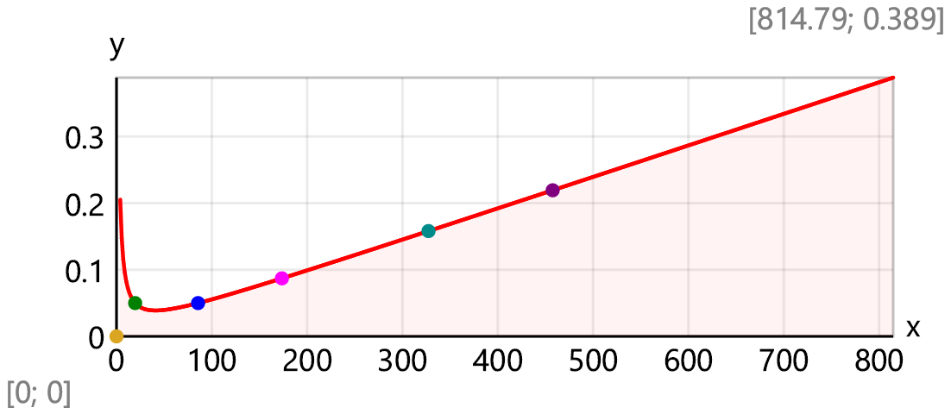

Damped natural frequences

Dynamic load vector

The equations of modal dynamic displacements are expressed by the Duhamel′s integral

Joint displacements

Comparison of time history records at midpoint for SDOF and MDOF systems

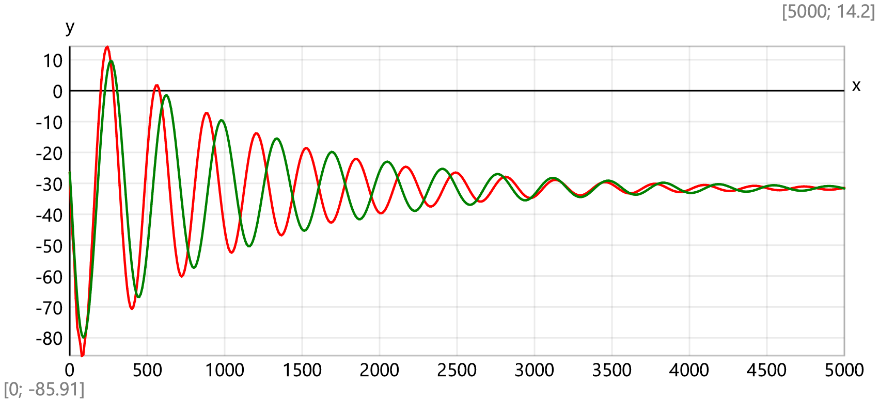

Time history records for separate joints

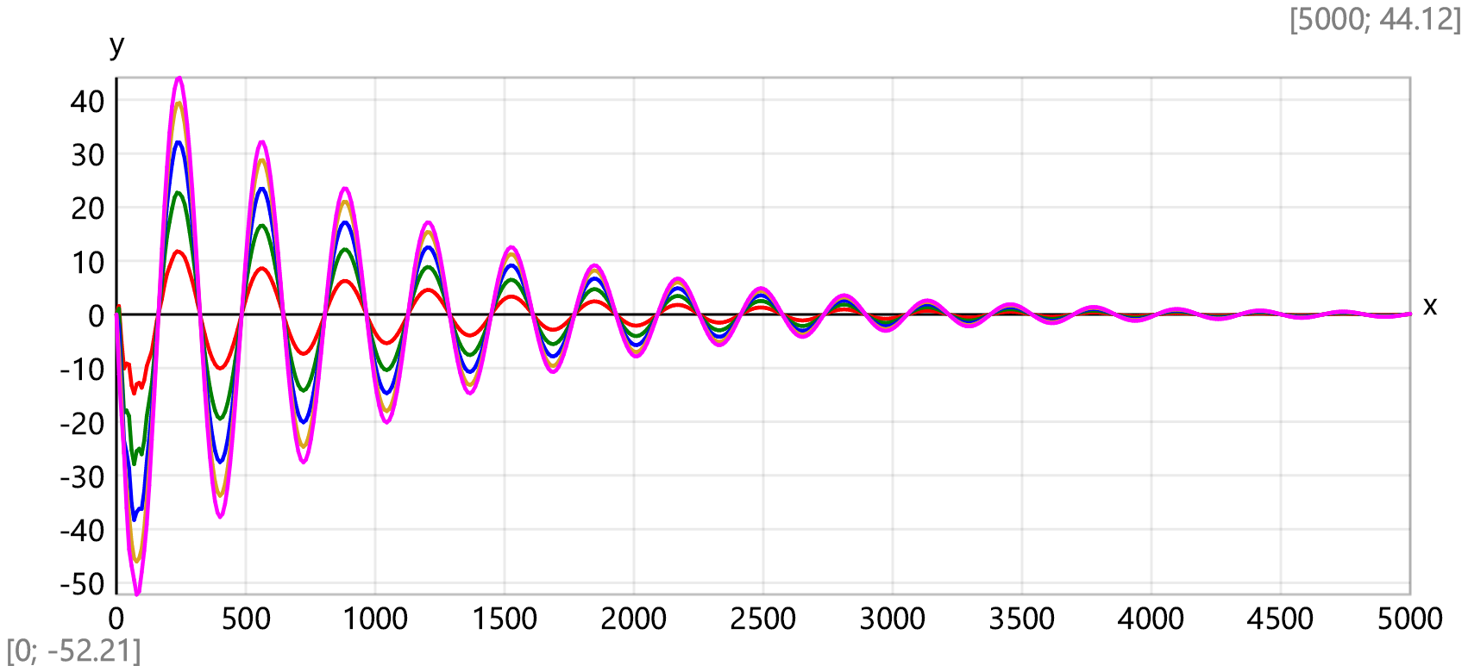

Beam deflections at the first five time steps of Δt = 17.7 ms

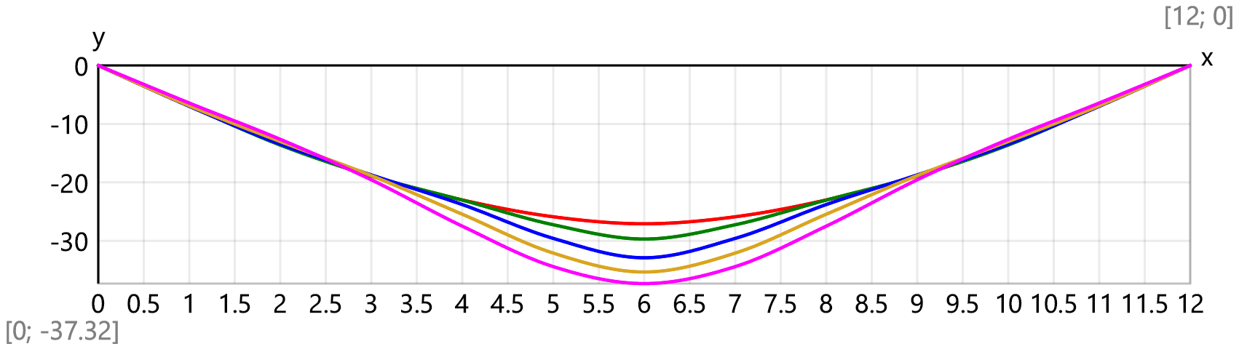

[1] Harris C. M., Piersol A.G., HARRIS’ SHOCK AND VIBRATION HANDBOOK, Fifth Edition, McGraw-Hill 2002, ISBN 0-07-137081-1

[2] Qing Peng, Xiaoming Liu, Yueguang Wei, Elastic impact of sphere on large plate, Journal of the Mechanics and Physics of Solids, Volume 156, 2021, 104604, ISSN 0022 - 5096, <https://doi.org/10.1016/j.jmps.2021.104604>

[3] Hong Hao and Thong M. Pham, Performance of RC Beams with or without FRP Strengthening Subjected to Impact Loading, Proceedings of the 2nd World Congress on Civil, Structural, and Environmental Engineering (CSEE’17) Barcelona, Spain – April 3– 4, 2017 ISSN:2371 - 5294 [DOI:10.11159/icsenm17.1](https://www.researchgate.net/publication/316618143_Performance_of_RC_Beams_with_or_without_FRP_Strengthening_Subjected_to_Impact_Loading)

[4] Gugan, D. “Inelastic collision and the Hertz theory of impact.” American Journal of Physics 68 (2000): 920-924., <http://www.oxfordcroquet.com/tech/gugan/index.asp>